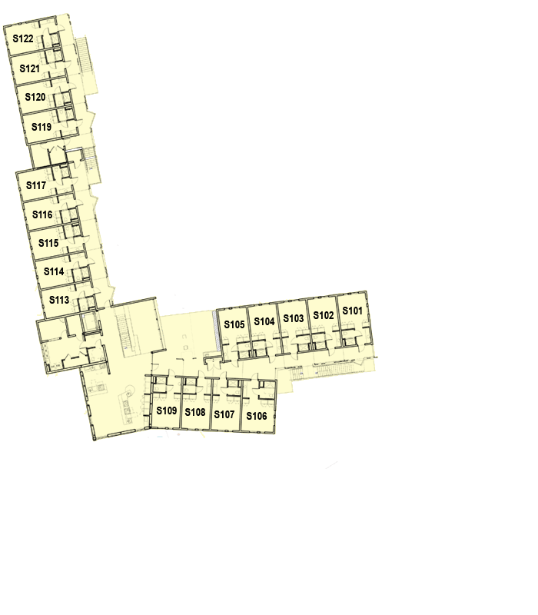

GLC Rooms S 101-105 and 108 will be Queen rooms

S106 is not available for rent.
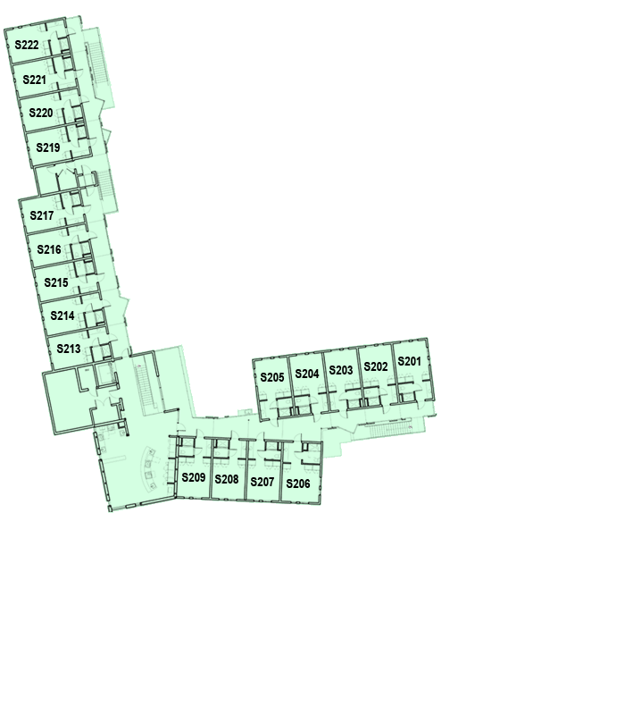

GLC Rooms S201-206 will be available Queen rooms. (S207, S207, S209 are sold for the summer)

We anticipate most of the GLC N second floor rooms to be available. The current group in the GLC N first floor may not be coming back, in which case the entire first floor would also be available to InterVarsity. I should know that by mid-February at the latest.

